SHARVARI BHONDEKAR - 07

EXPERIMENT - 7

SERVER
import socket
import threading

PORT = 5050
SERVER = socket.gethostbyname(socket.gethostname())
ADDR = (SERVER, PORT)
FORMAT = 'utf-8'
HEADER = 64
DISCONNECT_MESSAGE = '!DISCONNECT'
server = socket.socket(socket.AF_INET, socket.SOCK_STREAM)
server.setsockopt(socket.SOL_SOCKET, socket.SO_REUSEADDR, 1)
server.bind(ADDR)

def clientHandling(connection, address):
print(f'[NEW CONNECTION] {address} connected')
isConnected = True
while isConnected:
try:
messageLength = connection.recv(HEADER).decode(FORMAT)
if messageLength:
messageLength = int(messageLength)
message = connection.recv(messageLength).decode(FORMAT)
if message == DISCONNECT_MESSAGE:
isConnected = False
print(f'[{address}] {message}')
connection.send('Message Received'.encode(FORMAT))
except ConnectionResetError:
print(f"[ERROR] Connection lost with {address}")
break
connection.close()

def start():
server.listen()
print(f'[LISTENING] Server is listening on {SERVER}')
while True:
connection, address = server.accept()
thread = threading.Thread(target=clientHandling, args=(connection, address))
thread.start()
print(f'[ACTIVE CONNECTIONS] {threading.active_count() - 1}')

print('[SERVER STARTING] Server has been started...')
start()

CLIENT
import socket

PORT = 5050
SERVER = ''
SERVER = socket.gethostbyname(socket.gethostname())
ADDR = (SERVER, PORT)
FORMAT = 'utf-8'
HEADER = 64
DISCONNECT_MESSAGE = '!DISCONNECT'

client = socket.socket (socket.AF_INET, socket.SOCK_STREAM)
client.connect (ADDR)

def send (messages):
message = messages.encode (FORMAT)
messageLength = len (message)
sendLength = str (messageLength).encode (FORMAT)
sendLength += b' ' * (HEADER - len (sendLength))
client.send (sendLength)
client.send (message)
print (client.recv (2045).decode (FORMAT))

if __name__ == '__main__':
send('Hello World!')

send (DISCONNECT_MESSAGE)

OUTPUT :

SERVER
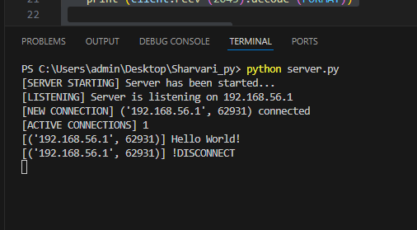

CLIENT
